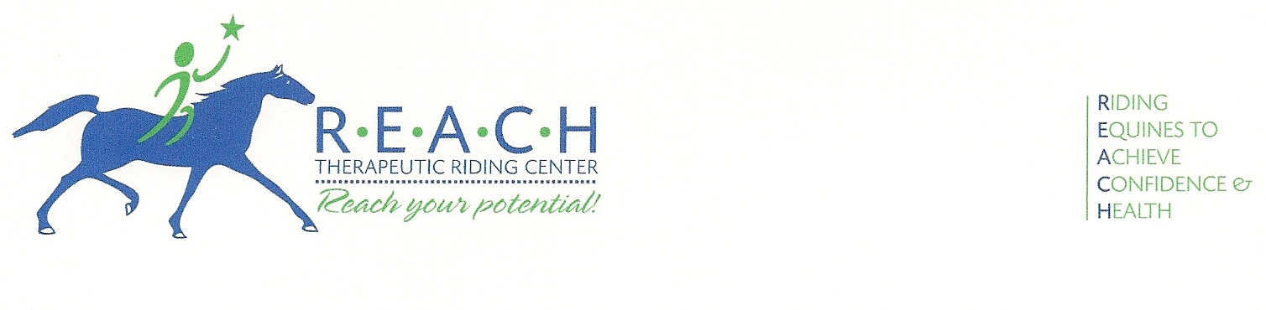
FOR IMMEDIATE RELEASE
November 5, 2013
For more information, contact Kim Hernandez
254-848-7888; Operations@REACHtrc.org

REACH THERAPEUTIC RIDING CENTER
RECEIVES COOPER FOUNDATION GRANT

Waco, Texas— Kim Hernandez, Interim Executive Director of REACH Therapeutic Riding Center, is pleased to announce the donation of $5,750 from the Cooper Foundation. The center plans to use the funds to make improvements to the center’s outdoor arena. Hernandez states, “The arena has suffered a lot of erosion over the years which creates a harder surface for our horses. Adding drainage and additional dirt will provide a safer and more comfortable surface for our horses to move on.”

REACH (Riding Equines to Achieve Confidence & Health) Therapeutic Riding Center, located in McGregor, is a non-profit corporation that provides therapeutic riding and hippotherapy. Therapeutic riding is the use of the horse and equine-oriented activities to achieve a variety of riding and therapeutic goals, including cognitive, physical, emotional, social, educational and behavioral improvements. Hippotherapy is a treatment strategy used by licensed therapists that utilizes equine movement as part of an integrated intervention program to achieve positive functional outcomes.

The Cooper Foundation was established in 1943 as a nonprofit, unincorporated trust wholly for the purpose of benevolent public usefulness. It was founded by Madison A. Cooper, Jr., as a memorial to his father and mother, the late Madison A. Cooper and Martha Roane Cooper.

Its mission is to make Waco a better or more desirable city in which to live. This is realized through support of experimental projects, research, surveys, and special community needs for which normal financing is not available.

For more information about the Cooper Foundation, visit www.cooperfdn.org. For more information about REACH Therapeutic Riding Center or to volunteer your time, please visit www.REACHtrc.org.

-30-
Photo caption:
Elizabeth Brient Smith, Executive Director of Cooper Foundation, presents a donation to Larry Barnett, Executive Director of REACH Therapeutic Riding Center. Volunteers Karen Fraser and Bob Chambers look on as rider Micah Holmes watches from the back of Simon.

