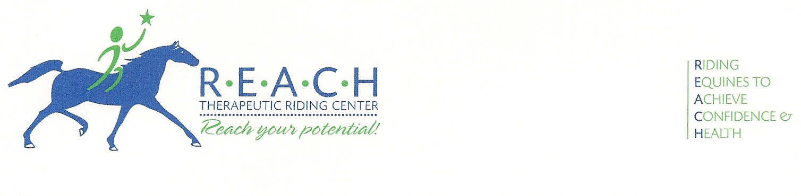
FOR IMMEDIATE RELEASE
February 24, 2012
For more information, contact Barbara Epps
254-848-7888; REACHtrc@earthlink.net

BOY SCOUT TROOP 308 DEDICATES NEW FLAGPOLE
TO REACH THERAPEUTIC RIDING CENTER AND
HORSES FOR HEROES VETERAN PROGRAM

Waco, Texas—REACH Therapeutic Riding Center is pleased to announce the dedication of the center’s new flagpole by Boy Scout Troop 308 and Eagle Scout candidate, Mitchell Spooner.

As part of his Eagle Scout requirement, Spooner chose to honor the veterans of the new Horses for Heroes program at REACH by designing and installing a flagpole and surrounding landscaping.

“

Horses for Heroes is a national program begun in 2005 to assist soldiers returning from Iraq and Afghanistan. Horses for Heroes strives to improve the lives of service men and women who have suffered injury in the line of duty, helping them to adjust physically and emotionally to their post-war lives. Participants must be approved by a physician and screened by a therapist, mental health professional and a therapeutic riding instructor. Soldiers with a diagnosis of PTSD, TBI, amputations, burns and neurological impairment may benefit from this service.

REACH (Riding Equines to Achieve Confidence & Health) Therapeutic Riding Center is a non-profit corporation that has been providing therapeutic riding and hippotherapy for nearly four years. Therapeutic riding is the use of the horse and equine-oriented activities to achieve a variety of riding and therapeutic goals, including cognitive, physical, emotional, social, educational and behavioral improvements. Hippotherapy is a treatment strategy used by skilled, certified and licensed therapists that utilizes equine movement as part of an integrated intervention program to achieve positive functional outcomes.

For more information about REACH Therapeutic Riding Center, the Horses for Heroes program, or to volunteer your time, please visit www.REACHtrc.org.

-30-

