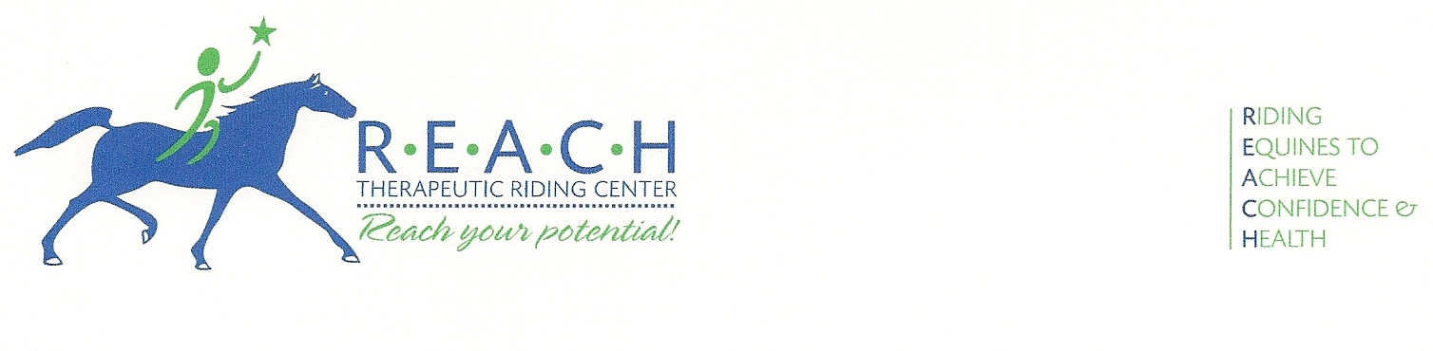
FOR IMMEDIATE RELEASE
September 20, 2013
For more information, contact Barbara Epps
254-848-7888; Marketing@reachtrc.org

REACH THERAPEUTIC RIDING CENTER
RECEIVES BRAZOS HIGHER EDUCATION GRANT

Waco, Texas—Kim Hernandez, Interim Executive Director of REACH Therapeutic Riding Center, is pleased to announce a donation of $10,000 from Brazos Higher Education Service Corporation. The center plans to use the funds to provide horseback riding scholarships for disabled individuals in the McLennan County area.

Murray Watson, President and Chief Executive Officer of Brazos Higher Education Service Corporation commented, “It is rewarding to see the fine work that is being carried on here to help these young disabled individuals as they grow up in a turbulent time.”

REACH (Riding Equines to Achieve Confidence & Health) Therapeutic Riding Center, located in McGregor, is a non-profit corporation that provides therapeutic riding and hippotherapy. Therapeutic riding is the use of the horse to achieve a variety of therapeutic goals, including cognitive, physical, emotional, social, educational and behavioral improvements. Hippotherapy is a treatment strategy used by skilled, certified and licensed therapists that utilizes equine movement as part of an integrated intervention program to achieve positive functional outcomes.

Brazos Higher Education Service Corporation (BHESC) is a local non-profit corporation with a mission of supporting education in McLennan County. Their mission: To make education a reality by supporting programs and initiatives to finance educational opportunities through all available means while delivering premier services to all our constituents. With their success over the past 25 years, BHESC has started a grant program to support the educational needs of the local community and make a difference in McLennan County.

For more information about Brazos Higher Education Service Corporation, visit www.brazos.us.com. For more information about REACH Therapeutic Riding Center or to volunteer your time, please visit www.REACHtrc.org.

-30-

Photo caption:
Murray Watson, President & CEO of Brazos Higher Education Service Corporation, presents a $10,000 donation to Shea Ruggles, Program Director of REACH Therapeutic Riding Center. Looking on : (left) Volunteer Bob Chambers, rider Michael Van Cleave on Gunner, and (right) Ellis Tredway, Executive Vice President of Brazos Higher Education Service Corporation.

