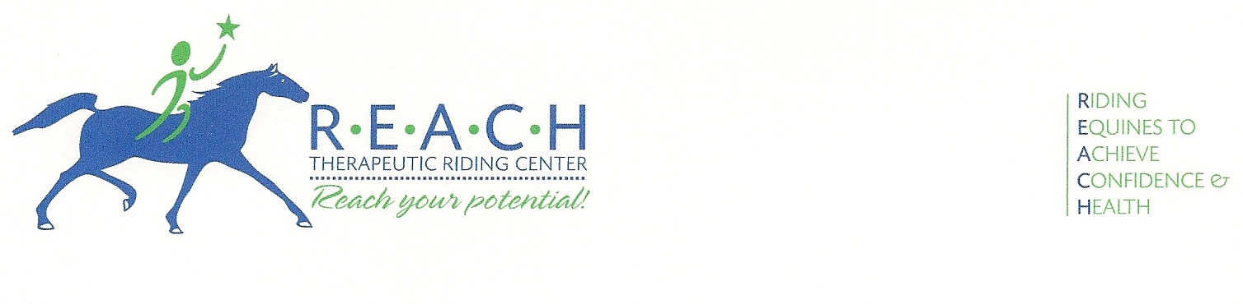
FOR IMMEDIATE RELEASE
March 22, 2012
For more information, contact Barbara Epps
254-848-7888; REACHtrc@earthlink.net

REACH THERAPEUTIC RIDING CENTER
RECEIVES JOY OF HOPE CONCERT FOUNDATION GRANT

Waco, Texas—Larry Barnett, Executive Director of REACH Therapeutic Riding Center, is pleased to accept a donation of $2,267.80 from the Joy of Hope Concert Foundation, to fund and aid wounded warriors in the Horses for Heroes program.

“It is our fervent hope,” says Les Kelso, president and founder of the Foundation and a Vietnam veteran himself, “this modest amount would start a much needed downhill snowball effect and garner even more financial support.”

Horses for Heroes is a national program that honors soldiers injured in service in partnership with the horse. Started in the fall of 2011 at REACH Therapeutic Riding Center in McGregor, Horses for Heroes is a growing program striving to reach and serve the wounded military and veterans of Central Texas.

REACH (Riding Equines to Achieve Confidence & Health) Therapeutic Riding Center, located in McGregor, is a non-profit corporation that provides therapeutic riding and hippotherapy. Therapeutic riding is the use of the horse and equine-oriented activities to achieve a variety of therapeutic goals, including cognitive, physical, emotional, social, educational and behavioral improvements. Hippotherapy is a treatment strategy used by skilled, certified and licensed therapists that utilizes equine movement as part of an integrated intervention program to achieve positive functional outcomes.

The Joy of Hope Foundation was established to raise funds to assist veterans returning from the Iraq and Afghanistan conflicts. The purpose and mission of the Foundation is to form and run concerts for the purpose of using proceeds to support programs directly linked to the care and recovery of war veterans and their families. Funds provide counseling, intervention, training, and peer support programs for these war victims and their families.

For more information about the Joy of Hope Concert Foundation, visit www.joyofhopefound.org. For more information about REACH Therapeutic Riding Center, the Horses for Heroes program, or to volunteer your time, please visit www.REACHtrc.org.
-30-

Photo caption:
Barbara Bowen-Kelso, Secretary of Joy of Hope Concert Foundation, presents a $2,267.80 donation to Larry Barnett, Executive Director of REACH Therapeutic Riding Center, as veterans and volunteers of the Horses for Heroes program look on.

