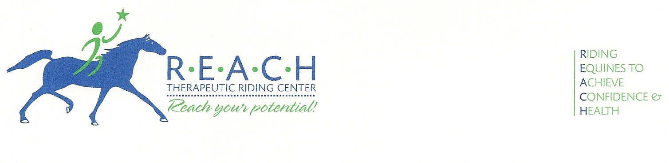
FOR IMMEDIATE RELEASE
24 April 2013
For more information, contact Barbara Epps
254-848-7888; Programs@REACHtrc.org

REACH THERAPEUTIC RIDING CENTER
THIRD ANNUAL HORSES FOR HEALING BENEFIT HUGE SUCCESS

McGregor, Texas—“The smell of horses is like the aroma of angels,” says 12-year-old Phillip.

And why is this important? Phillip has autism, a cognitive disability that affects one in 54 boys, making communication and interaction a daily challenge. For someone with autism, this kind of verbal expression can be rare, but that day Phillip clearly communicated his feelings about REACH Therapeutic Riding Center.

Since 2007, miracles like this happen every day at the barn and arena of REACH. Each week, nearly 50 riders receive this life-changing therapy and a new sense of self-confidence and freedom.

REACH (Riding Equines to Achieve Confidence & Health) Therapeutic Riding Center is a 501(c)(3) non-profit corporation that provides horseback riding to disabled individuals. “Riding a horse provides physical, emotional, social, educational and behavioral benefits to people with a variety of disabilities,” explained Barbara Epps, Program Director. “The walking movement of the horse is very similar to the walking gait of a human, providing muscular and mental stimulation to someone who may have difficulty processing normal stimuli.”

“You’re opening up a whole new world for many, including Jamie … it looks like it’s a world he’s going to enjoy exploring,” said Anita Karney, president of the Heart of Texas Autism Network, and mother of eleven-year-old Jamie.

Funding for a therapeutic riding program comes mainly from contributions. “Less than 35% of our budget comes from fees we collect directly from the riders. The other 65% plus comes from donations,” said Larry Barnett, Executive Director. “In order for REACH to grow and provide this service to more Central Texans, we are continually challenged to find ways to raise money.”

An annual fund-raising event of REACH is the Horses for Healing Dinner, now in it’s third year. More than 180 people purchased tickets to the event April 22, which included a Parade of Schools Horse Fashion Show live auction, silent auction items donated by local individuals and businesses, a barn buffet and live music.

Horses for Healing exceeded fund-raising goals this year. “The unbelievable outpouring of support from the community is overwhelming and will allow us to continue our mission,” said Barnett. “Thank you to all our sponsors, donors, attendees, volunteers and families who support us and our riders.”

For more information about REACH Therapeutic Riding Center, to volunteer your time, or make a donation, please call 254-848-7888, email Ride@REACHtrc.org, or visit www.REACHtrc.org.

-30-

