­­­­

**2024 Sponsorship Opportunities**

What is REACH?

REACH Therapeutic Riding Center is a place where miracles happen daily. Children with autism focus and thrive. Physically challenged riders discover independence and self-confidence. Mentally challenged riders channel behavior and increase motivation. Veterans find acceptance.

Our mission is simple. We want to improve the health, increase the confidence, and promote the independence of persons with special needs through the use of horses.

Why Horses?

The bond between horse and human is undeniable – and well documented. In a variety of ways, interacting with horses helps people with special needs to reach their greatest potential.

Why We Need YOU!

With your support as a Sponsor for the 2024 Horses for Healing Benefit at the Barn, you help us continue to change lives of the children and adults with special needs. Your support also allows us to continue our programs for active and retired military at no cost to our Heroes!

Thank you for your time and consideration for being a 2024 Horses for Healing Benefit Sponsor! Without your support none of this would be possible!

**Sponsorship Opportunities**

**$15,000.00 – Presenting Sponsor: Amenities** ONLY ONE WILL BE SOLD

* Two Reserved Tables for Ten (20 Tickets)
* Prominent Full Panel Banner Displayed All Year Long
* Preferred Seating
* TV & Print Media
* Presenting Sponsor representative can be present during media interviews if desired
* Logo/Link on Website
* Express VIP Check In
* Event Sponsor Board
* Multiple Social Media Mentions
* Official Sponsor Recognition

**$10,000.00– Supreme Champion: Amenities**

* Two Reserved Tables for Ten (20 Tickets)
* Prominent Full Panel Banner Displayed All Year Long
* Preferred Seating
* TV & Print Media
* Band Mentions
* Event Sponsor Board
* Social Media Mentions
* Official Sponsor Recognition

Sponsorship Opportunities (Pick One):

EVENT SIGNAGE:

* Band Sponsor

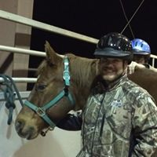 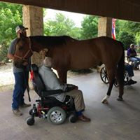 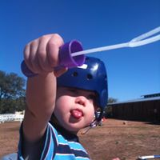 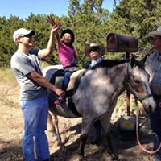

**$7,500.00 – Grand Champion: Amenities**

* One Reserved Tables for Ten (10 Tickets)
* Prominent Full Panel Banner Displayed All Year Long
* Preferred Seating
* TV & Print Media
* Band Mentions
* Event Sponsor Board
* Social Media Mentions
* Official Sponsor Recognition

Sponsorship Opportunities (Pick One):

EVENT SIGNAGE:

* Stage Sponsor
* Catering Sponsor

**$5,000.00 – Reserve Grand Champion: Amenities**

* One Reserved Tables for Ten (10 Tickets)
* Prominent Full Panel Banner Displayed All Year Long
* Preferred Seating
* Event Sponsor Board
* Social Media Mentions
* Official Sponsor Recognition

Sponsorship Opportunities (Pick One):

EVENT SIGNAGE:

* Silent Auction
* Audible Horse Auction
* Audible Auction
* Step and Repeat Entry Wall
* Koozie at Bar--SOLD

**$2,000.00 – Riders Award: Amenities**

* One Reserved Tables for Ten (10 Tickets)
* Prominent Half Panel Banner Displayed All Year Long
* Preferred Seating
* Event Sponsor Board
* Social Media Mentions
* Official Sponsor Recognition

Sponsorship Opportunities (Pick One):

EVENT SIGNAGE:

* Bar Sponsor (4 Available)
* Beverage Napkin
* Photo Booth Sponsor

**$1,500.00 – Master’s Challenge Award: Amenities**

* Six (6) Tickets
* Quarter Panel Banner Displayed All Year Long
* Event Sponsor Board
* Official Sponsor Recognition

Sponsorship Opportunities (Pick One):

EVENT SIGNAGE:

* Wine & Spirits Pull

**$1,000.00 – Gold: Amenities**

* Four (4) Tickets
* Quarter Panel Banner Displayed All Year Long
* Event Sponsor Board
* Official Sponsor Recognition

Sponsorship Opportunities (Pick One): EVENT SIGNAGE:

* Reservation/Check-In
* Check-Out
* Centerpieces (4 Available)